Lab 5 – Madlibs / Random Numbers
PART 1:
In the game of Madlibs you take a famous quote, a common phrase, even a song lyric and prompt the user for words which you then plug into the quote / phrase / lyric to come up with a wacky new version.
In this part of the lab activity you are going to create a program with Visual Studio that will play Madlibs with the user. You need to make up 3 different phrases or quotes to turn into Madlibs. You should then write a program that prompts the user for several words and prints out Madlib phrases. Sample program output is shown here:
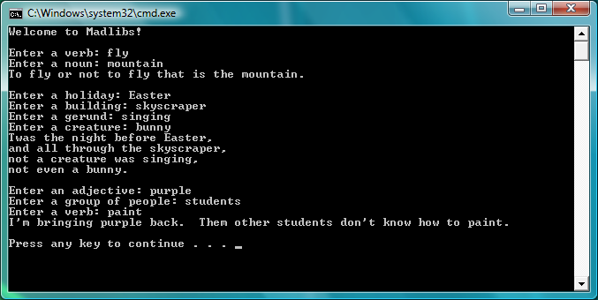
In this lab activity you will make use of the string variable type, which can store a word or phrase. You declare a variable for use in your program by giving it a type and then a name (note: variables must be declared before they can be used). For example,

string noun;

would declare a variable called “noun” that could hold a word or phrase. For this lab activity you will also need to get input from the user. You can retrieve user input from the keyboard with the cin command. Thus, if I wanted to have the user type in a word at the keyboard, store it in a string variable, and then print it back out to the screen I could put the following code in my main() function:

string word;
cout << “Please enter a word: “;
cin >> word;
cout << “You typed “ << word << “ to the screen” << endl;

NOTE: To use variables of type string you need to #include the string library at the top of your program (in addition to iostream, which allows you to use both cin and cout) as shown below:

#include<iostream>
#include<string> //must include this to use the string type
using namespace std;
// … rest of program code

PART 2:

For this part of the activity you are going to create a simple random number generation program. Your program should ask users for the lowest possible random integer they want generated and then the largest possible random integer they want generated. The program should then choose a random number in this range and print it to the screen. Here are some examples.
1. If I wanted to simulate rolling a six sided dice I would enter 1 for the lowest possible random integer and 6 for the largest possible random integer.
2. If I wanted to simulate rolling a twenty sided dice I would enter 1 for the lowest possible random integer and 20 for the largest possible random integer.
3. If I wanted to generate a random integer between 10 and 20 (inclusive) I would enter 10 for the lowest possible random integer and 20 for the largest possible random integer.
Possible output for such a program might look as follows (user input in bold):
Enter the smallest integer in the random number range: 1
Enter the largest integer in the random number range: 6
Random number between 1 and 6: 5

Your program should not produce the same random number each time it is run, even if it is given the same inputs. You can just add the code for this part of the lab after the code for Part 1 of the lab. Submit one .cpp file for this lab activity.

